POC -4

**ABDUR RAHMAN**

IIND YEAR-CSE

**Creating a Simple Backup Script for a Git Repository on Windows**

**Step 1: Create the Backup Script**

**1.Open Notepad or any text editor**

**2.Make changes accoding to your preferences**

@echo off

set SOURCE=c/Users/pcabd/codsoft

set DESTINATION=C:\AWS\gitbackup

set LOGFILE=C:\AWS\gitbackup\gitlog.txt

echo Backup started: %DATE% %TIME% >> %LOGFILE%

robocopy "%SOURCE%" "%DESTINATION%" /E /COPYALL /R:3 /W:5 /LOG:%LOGFILE% /NP

echo Backup completed: %DATE% %TIME% >> %LOGFILE%

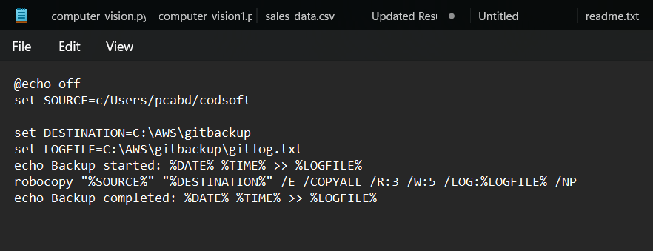

**why because this is your repo and the repo is copy in your backup when its is starts to run**

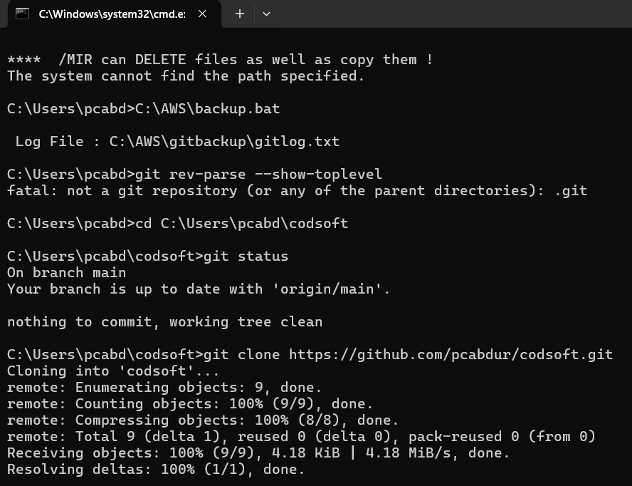

**Step 2: Automate with Task Scheduler**

1. Open **Task Scheduler** (Win + S, search "Task Scheduler").
2. Click **Create Basic Task**.
3. Enter a **name** (e.g., "Git Backup") and **description**, then click **Next**.
4. Select **Daily** (or any frequency you prefer) and click **Next**.
5. Set the **time** for the backup to run and click **Next**.
6. Choose **Start a Program** and click **Next**.
7. Click **Browse**, select backup.bat, and click **Next**.
8. Click **Finish** to save the task.

**Step 3: Verify Automation**

1. In **Task Scheduler**, find the task under **Task Scheduler Library**.
2. Right-click the task and select **Run** to test it.
3. Check C:\GitBackup and backup_log.txt to ensure the backup was created.

**THANK YOU !!**